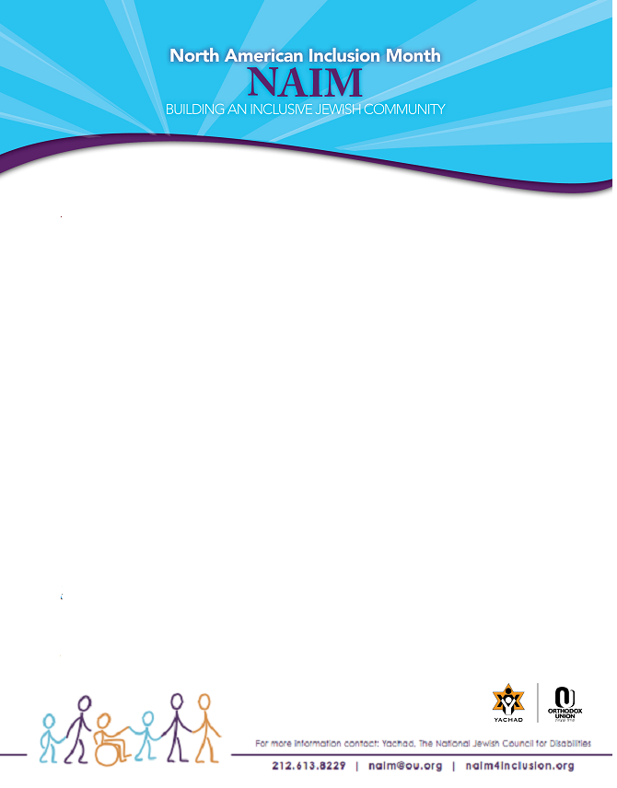
Houston Yachad – NAIM Celebration
The Houston Yachad chapter will celebrate NAIM by hosting Dr. Jeff Lichtman, National Director of Yachad/NJCD, February 18 – 20th with a weekend of programs, workshops and discussions. Dr. Lichtman is a dynamic speaker with an extensive background in this area. He is a psychologist with Rabbinical training from Yeshiva University. Dr. Lichtman has worked as a teacher, school psychologist, and a principal in both Jewish and public school and regular and special education settings

IQ/EQ: Who Do You Want To Be / Who Do I Want My Child To Be?
Dr. Jeff Lichtman – National Director of YACHAD/NJCS
This discussion is for middle schoolers, high schoolers, and adults.
Friday, February 18th – 8:45 pm at UOS – 9001 Greenwillow
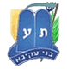
Bnei Akiva / Yachad
Second – Eighth Graders
Saturday, February 19th 4:45 -5:45 pm at UOS - 9001 Greenwillow
High Schoolers with Dr. Jeff Lichtman
5:45 pm Mincha – program and Seudash Shlishit and Havdallah

Fostering Intellectual and Emotional Development in Children
Community Discussion with Dr. Lichtman
This discussion is open to the community.
Saturday, February 19th at 8:00 pm at the home of Rabbi Avi & Dr. Shulamis Pollak
For more information, contact Jennifer Raskas - jen.l.rubin@gmail.com

Yachad at Yom Limmud
Relationship Building: Social Skills Training for Children with Special Needs
The Family Circle: An Open Discussion with Parents and Siblings of Children with Special Needs.
Led by Dr. Jeff Lichtman
Sunday, February 20th at Congregation Emanu El 1500 Sunset Blvd.
Houston Yachad / Bnei Akiva Events – Spring 2011
Chevraya Aleph is 2nd – 8th Grade
Chevraya Bet is 9th – 12th Grade

February 18 – 20th – Shabbaton/ Yom Limmud with Dr. Lichtman
Saturday afternoon Snif Chevraya Aleph 4:35 – 5:35 pm
Mincha at 5:35 pm / Chevraya Bet 5:50 pm

March 19th – Bnei Akiva / Yachad Snif at UOS -9001 Greenwillow
Saturday afternoon Snif Chevraya Aleph 5:55 – 6:55 pm
Mincha at 6:55 pm / Chevraya Bet 7:10 pm

April 2nd – Bnei Akiva / Yachad Snif at UOS – 9001 Greenwillow
Saturday afternoon Snif Chevraya Aleph 6:05 – 7:05 pm
Mincha at 7:05 pm / Chevraya Bet 7:20 pm

May 13 – 14th – Statewide Yachad Shabbaton at UOS – 9001
Kabblat Shabbat 7:45 pm
Shabbat Dinner after services
Shabbat Services and programming
Shabbat Lunch
Final Bnei Akiva / Snif
Details to follow

